Lab 1

Brandon P Trinkle

Arizona State University

Course Number: IFT 220

Professor Betty J. Lauer

March 16, 2024

Lab 1

Part A:

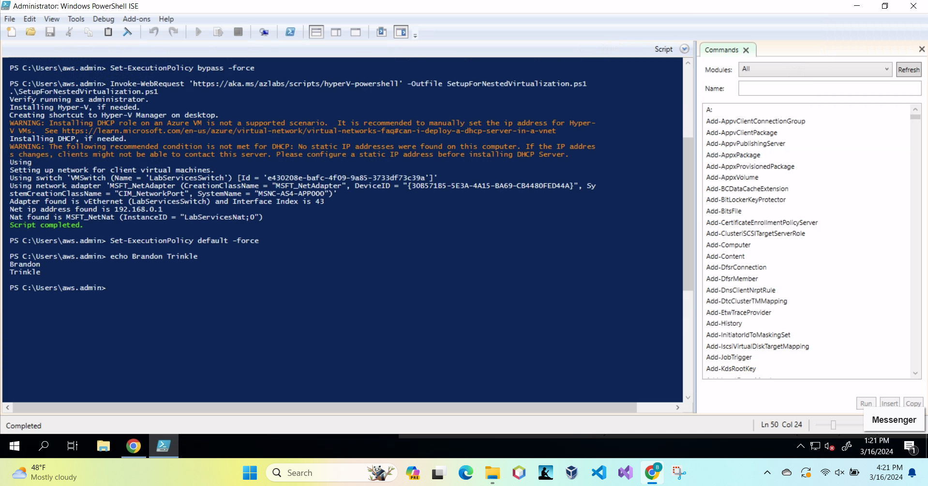

Part B:

DC01 Settings:

Screenshot of the device name:

Screenshot of administrator name:

Successful ping to PC01:

DC01 Settings:

Screenshot of device name:

Screenshot of Administrator name:

Screenshot of successful ping to server:

**Summary**

Setting up two virtual machines (VMs) with Windows Server and Windows 10 is a meticulous process crucial for establishing a dependable computing environment. It initiates with accessing the ASU Engineering Technical Services site via Google Chrome to procure essential ISO files for Windows Server 2022 and Windows 10, along with their corresponding installation keys. These files serve as the backbone for configuring the VMs, ensuring seamless operation within a virtualized ecosystem. Leveraging the Windows Hyper-V Manager tool, the setup journey progresses with the creation of a VM tailored for Windows Server. This entails fundamental configurations such as setting the computer name to DC01, configuring IPv4 addresses, and deactivating firewalls with precision, laying the groundwork for a stable operating environment. Following the creation of the Windows Server VM, the setup process pivots towards creating a virtual machine dedicated to the Windows 10 client. Similar foundational settings are replicated, including designating the computer name as PC01, configuring IPv4 addresses, and deactivating firewalls, ensuring consistency across the virtualized environment. Once both virtual machines are set up, proper shutdown methods are required to ensure the environment is safely shut down, safeguarding the platform's integrity and efficiency for seamless computing experiences. This shutdown process from the virtualized environment ensures smooth operation and sets the stage for optimal performance.

A closer examination of this setup process reveals a systematic approach deeply rooted in adherence to guidelines and best practices. Accessing the ASU Engineering Technical Services site marks the initial step, providing access to indispensable resources crucial for VM creation. Within the Windows Hyper-V Manager, the creation of the VMs is meticulously executed, guided by precision and attention to detail. Establishing a Virtual Switch named "Enterprise" facilitates seamless communication within the virtualized ecosystem, ensuring optimal performance and connectivity. Post-installation, meticulous attention is devoted to configuring network settings, including IP addresses, DNS settings, and firewall deactivations, across both VMs. A crucial validation step involves conducting a validation test confirming a connection between both PC01’s and DC01’s virtual environment through successful ping responses from DC01 to PC01 and vice versa. This validation ensures that the communication channels between the VMs are functioning effectively, setting the stage for robust operation. Finally, the setup process concludes with a graceful shutdown ritual, ensuring the proper cessation of VMs, Hyper-V closure, and orderly environment shutdown. This comprehensive approach, supported by pertinent documentation and adherence to guidelines, epitomizes the essence of a robust virtualization endeavor, poised to cater to diverse computing needs adeptly. (Lauer, 2024)

Overall, this process did require me to reacclimate myself to hyper-v. One suggestion that

would have made this lab a little better is clear and concise instructions. The instructions were not clearly written, and some of the instructions were just incorrect. For example, it would have been good to include that you need to press a button when first opening the machine from boot, or it will not mount the ISO image. I spent about four hours configuring the server multiple times, only to realize I wasn’t hitting a button on the initial boot. Additionally, when setting the admin and user names, the folders and directories we are instructed to go to aren’t correctly labeled. I was able to figure it out, but again, I learn through repetition, not through troubleshooting and clicking into different folders to find settings.

# References

Lauer, B. J. (2024, March 16). *Module 1/Lab 1*. Retrieved from Canvas IFT-220: https://canvas.asu.edu/courses/182822/assignments/5006774?module_item_id=13141821